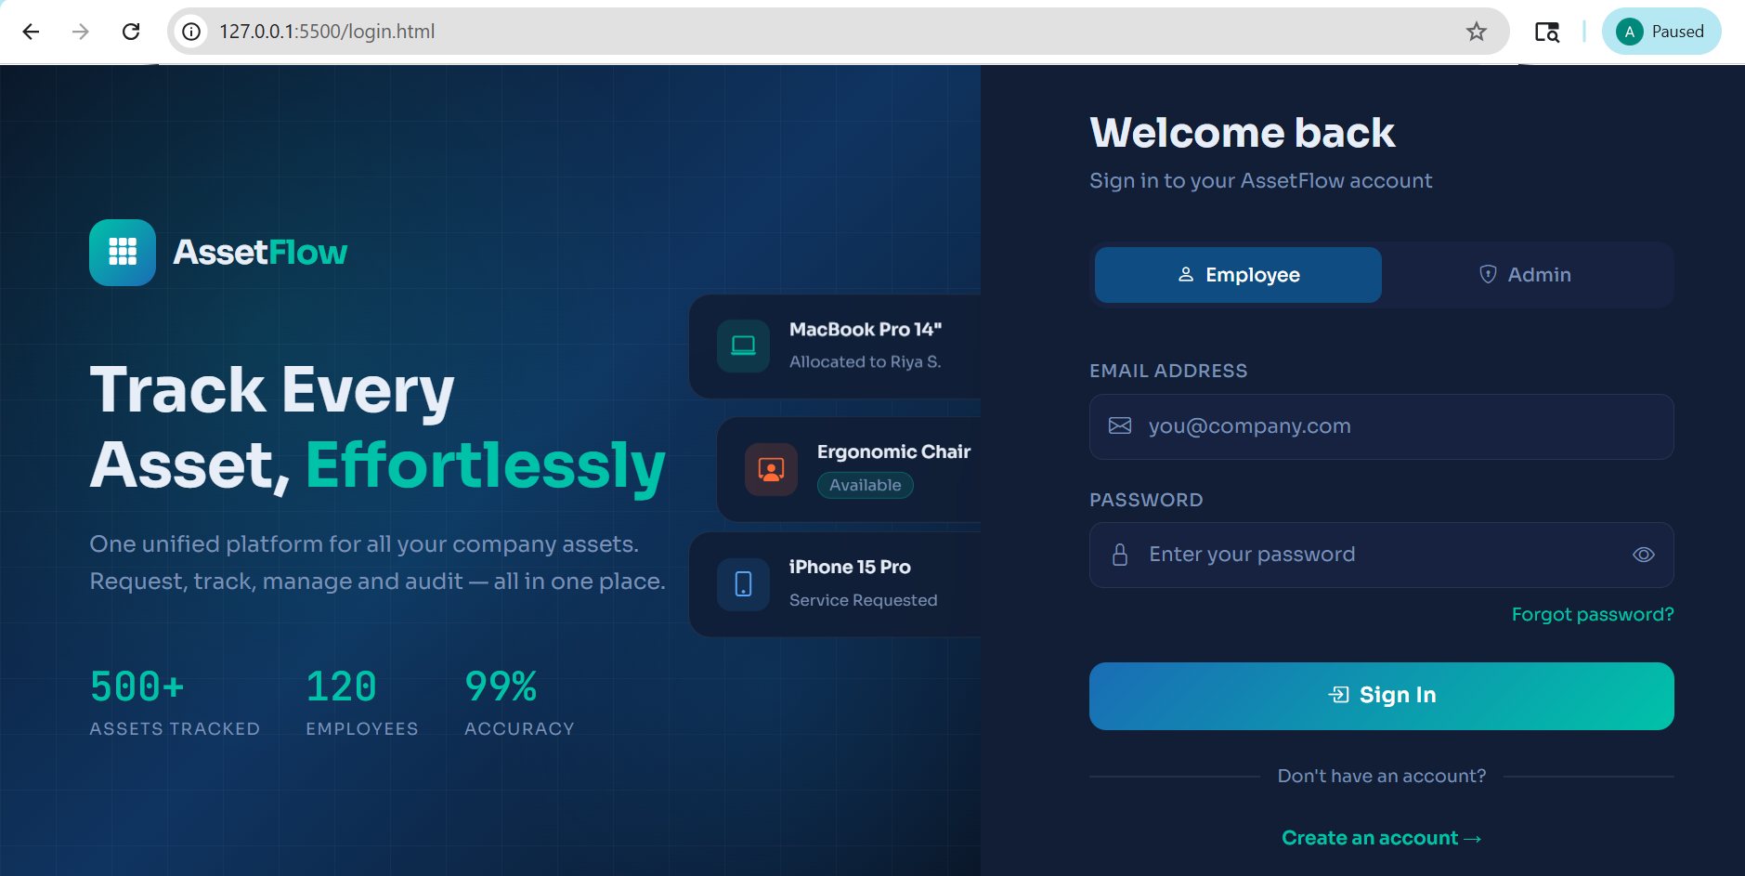
- Login Page for Employee and Admin

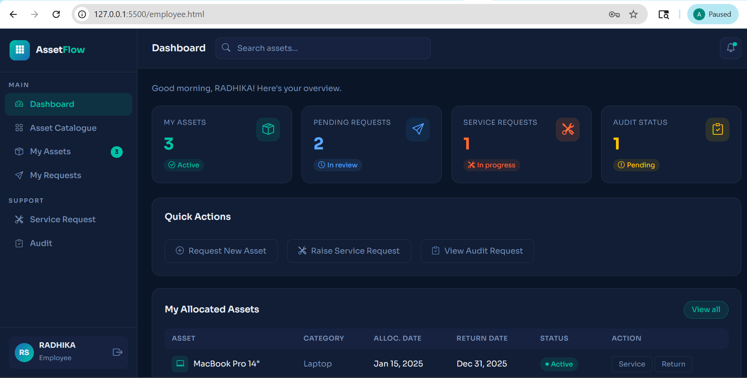
- Employee Dashboard

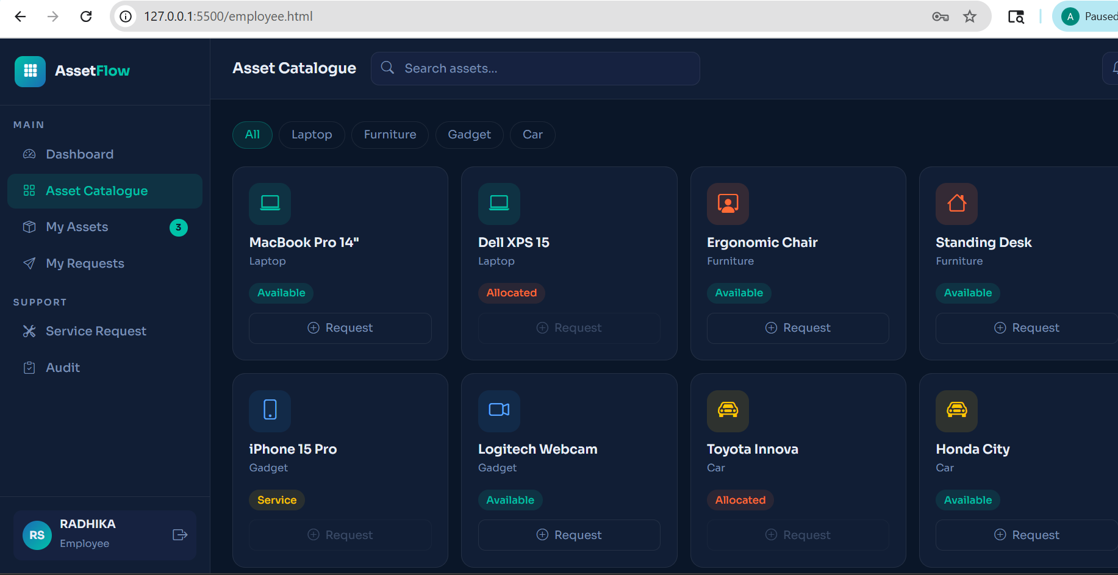
- ASSET CATALOGUE

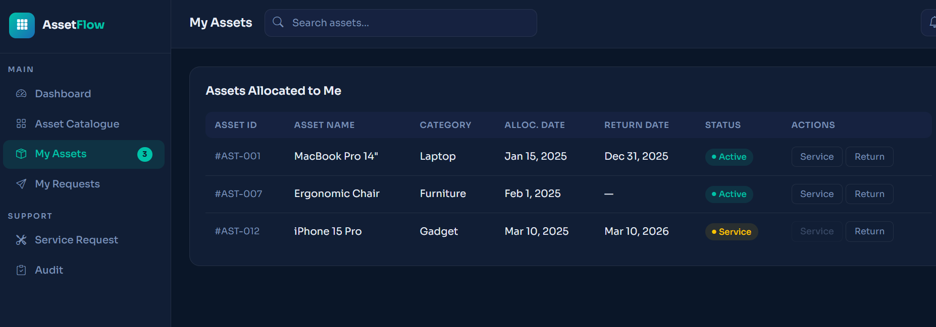
- EMPLOYEE’S ASSETS

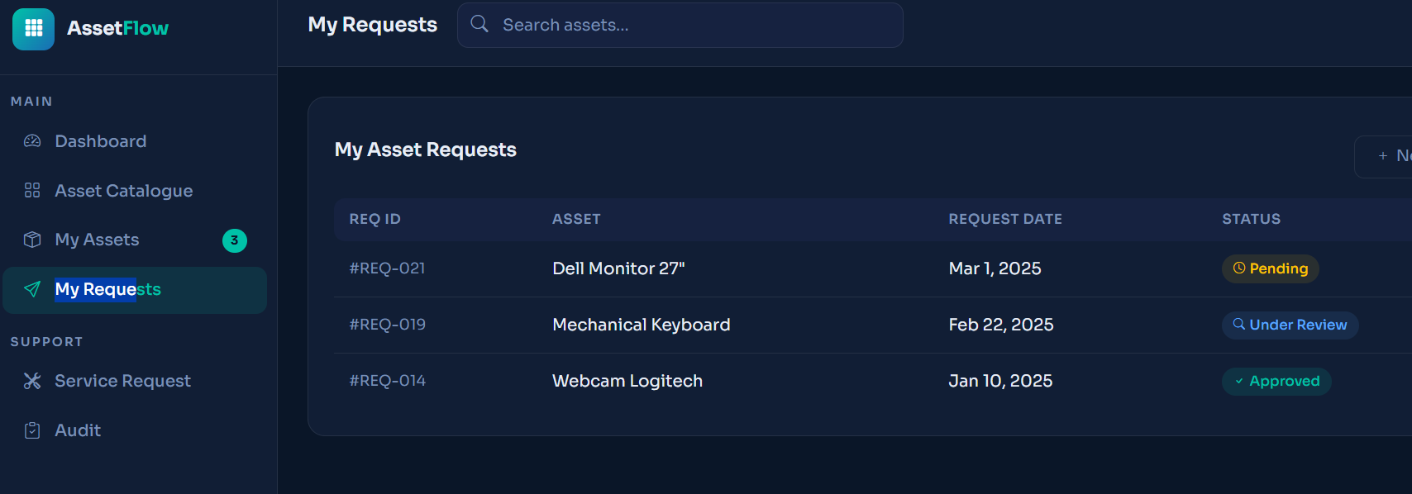
- EMPLOYEE’S ASSET REQUESTS

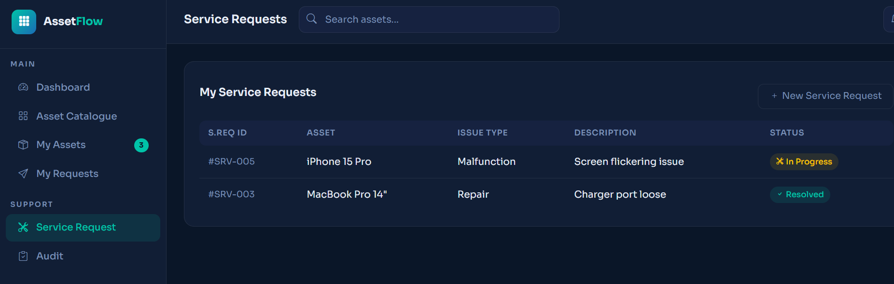
- EMPLOYEE’S SERVICE REQUESTS

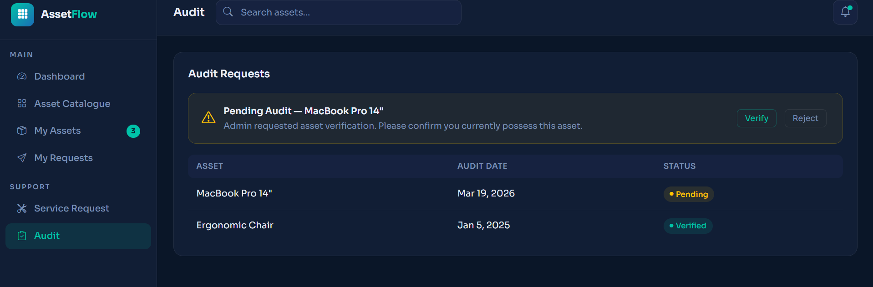
- AUDITS

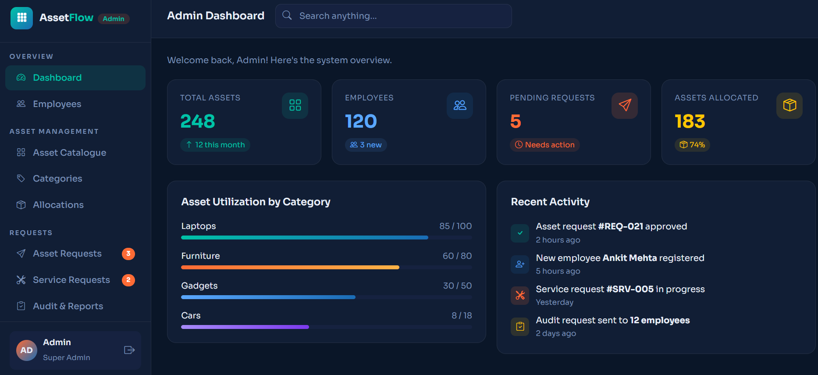
- ADMIN DASHBOARD

